
Carrowreagh Primary School



Bee part of our school

Prospectus 2023/24

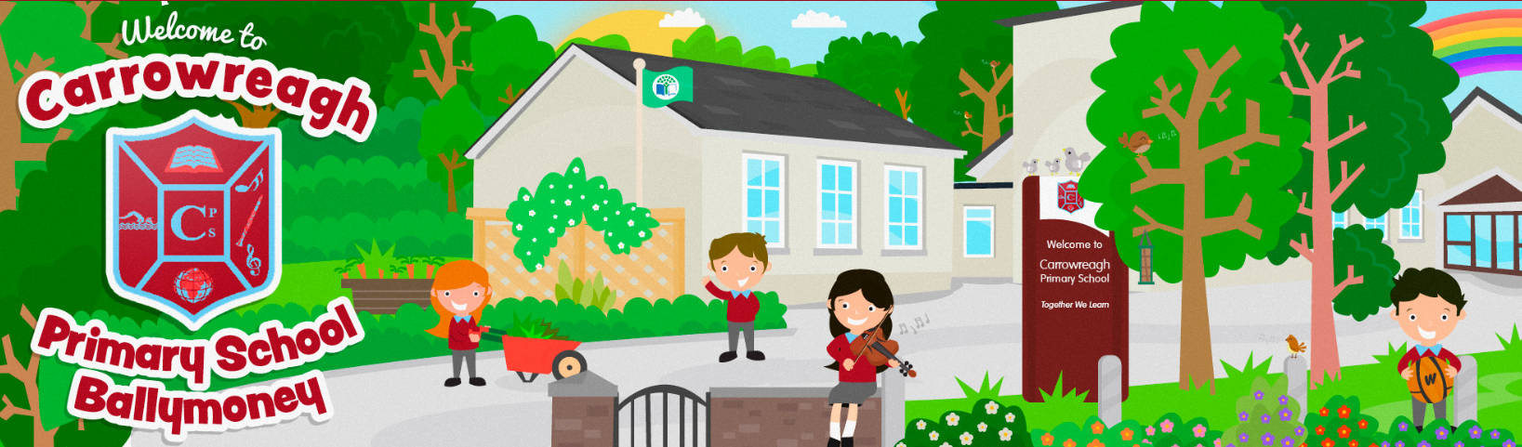

Carrowreagh Primary School
110B Finvoy Road
Ballymoney
Co Antrim
BT53 7JL

Principal: Mrs. D Crawford BEd. (hons) PQH NI

Tel No. 028 276 62440
Email: info@carrowreaghps.ballymoney.ni.sch.uk
www.carrowreaghps.com

Carrowreagh Primary School is located approximately 3 miles from Ballymoney, on the Finvoy Road.

The original school was opened in 1870 and the building has been added to several times over the years. In 2004 the school underwent a major refurbishment and extension when a new classroom was added, as well as a staff room, office, principal’s office, and bright, welcoming reception area.
Part of our school grounds has been converted into a nature garden area which includes a willow dome, seating areas, a butterfly garden and pupil planting beds. In recent years we planted a Field of Hope in aid of Marie Curie Cancer Care at the front of the school.

The school has been awarded the prestigious Eco-Schools Green Flag eight times.

Winners of WWF Green Ambassadors for Northern Ireland Award 2017.





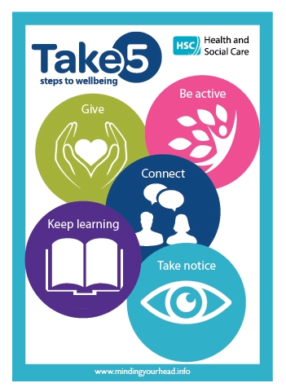








Board of Governors

Our Board of Governors

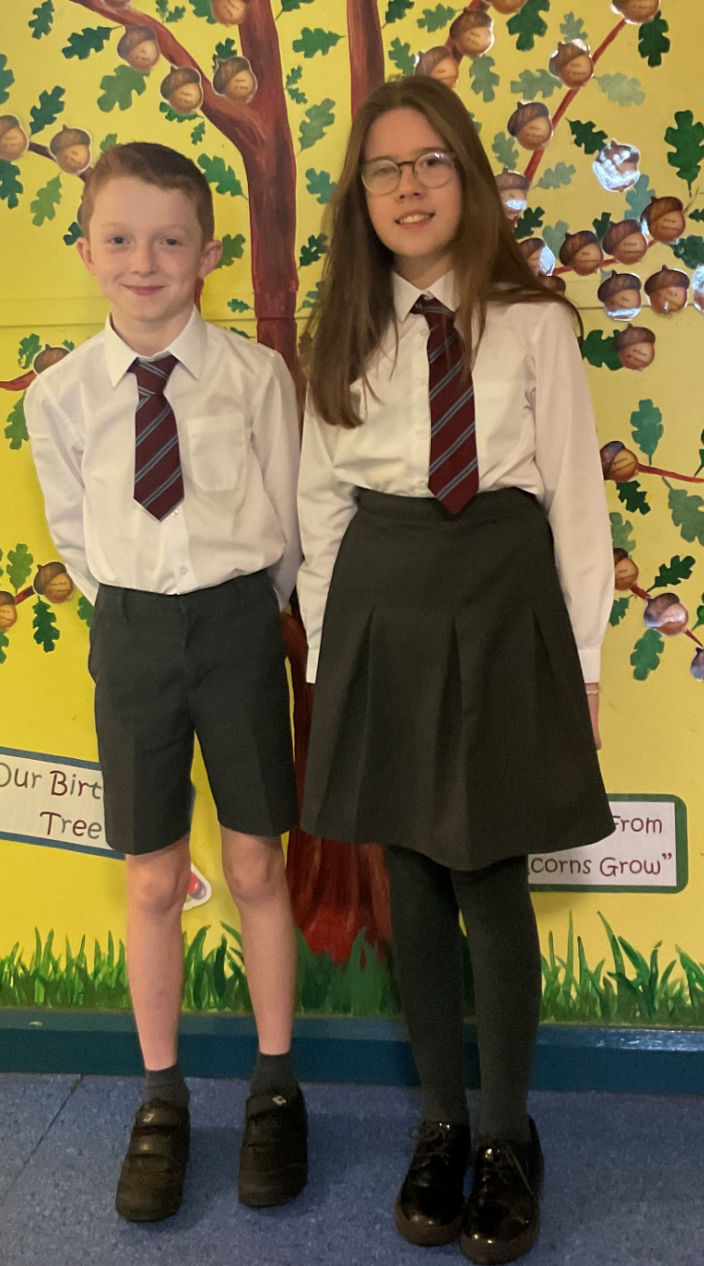
Nominated by EA
Mrs P Hayes (Chairperson)

Nominated by Transferors
Rev R Gaston
Mr J Blair
Mr J Dysart
Mr M Faulkner

Nominated by Parents
Mrs E Bellingham
Mr I McClelland

Nominated by Teachers
Mrs R Hall

Non-voting member
Mrs D Crawford (Honorary Secretary)

Our Teaching Staff

Mrs D Crawford B.Ed. (Hons) PQH(NI) Principal P2/3
Mrs C Young B.A. (Hons) P4/5
Mr M Bellew B.Sc. (Hons) P.G.C.E. P6/7
Mrs R Hall B.Ed. (Hons) Rec/P1
Our Ancillary Staff

Mrs P Morrison (School Secretary)
Mrs P Shannon (Caretaker and Supervisor)
Mrs N Jamieson (Classroom Assistant and Supervisor)
Mrs O Ogborne (Classroom Assistant)
Mrs V Walker (SEN Classroom Assistant/Supervisor and Cleaner)
Ms J Friel (SEN Classroom Assistant)
Miss A O’Brien (SEN Classroom Assistant)
Ms E Wallace (School Meals Assistant)
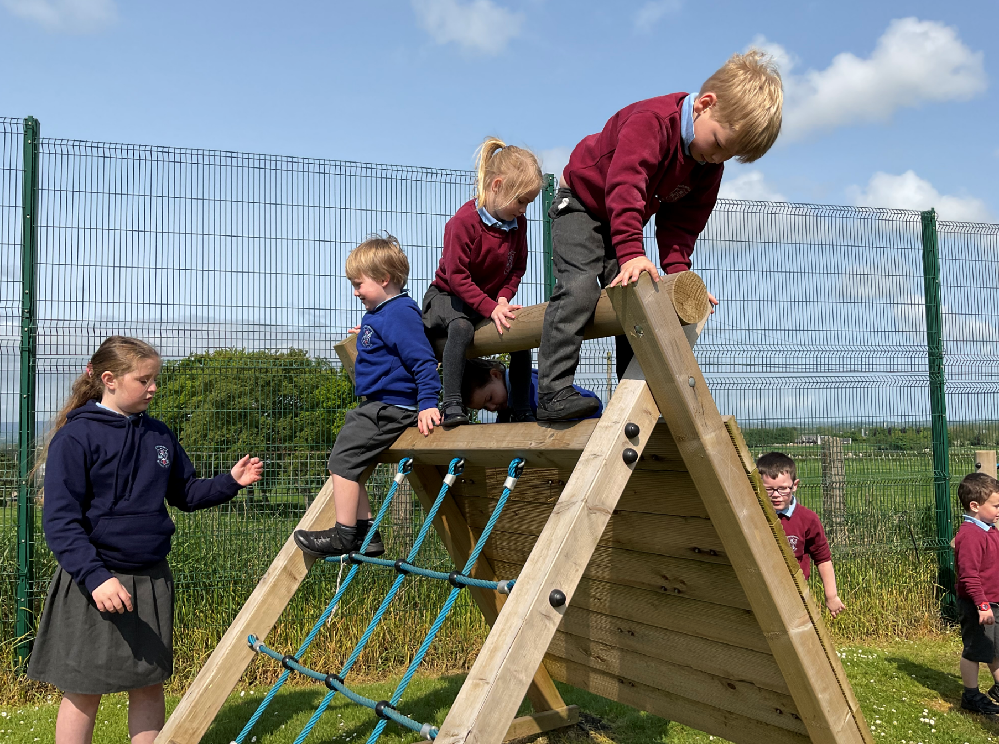

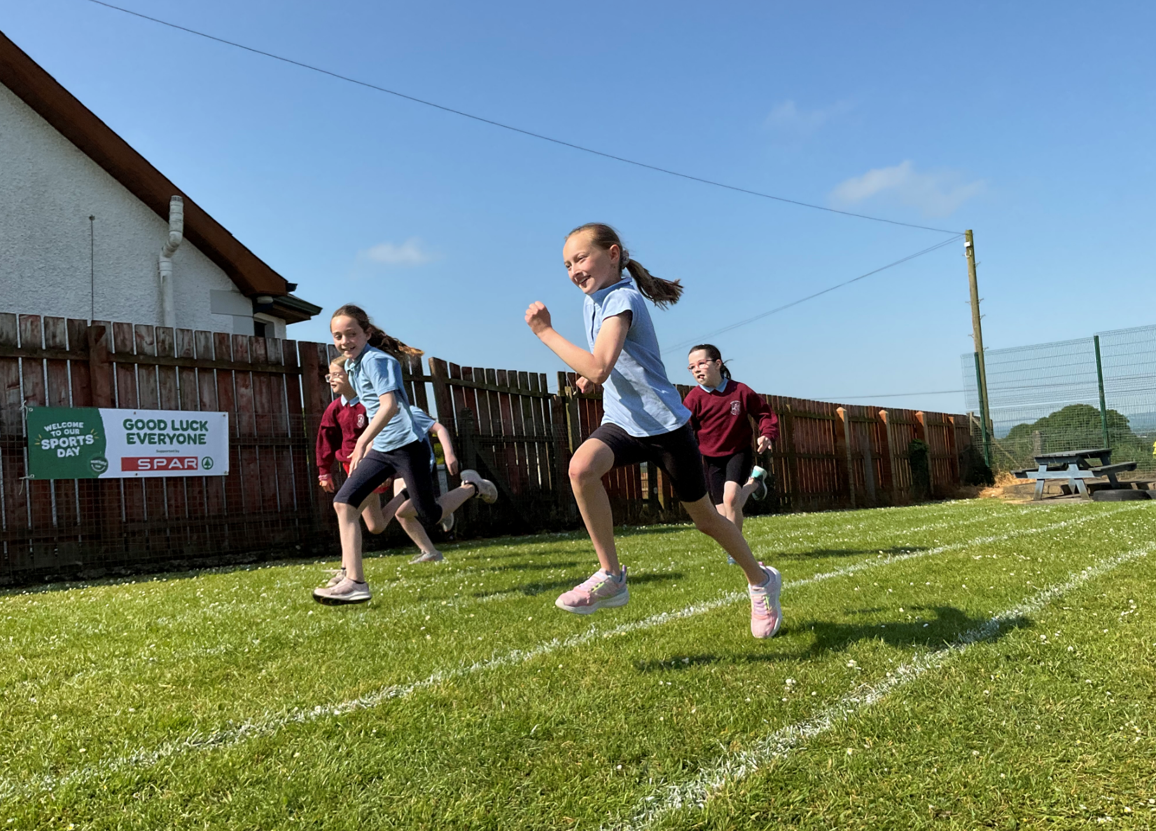

ADMISSIONS

ADMISSIONS CRITERIA – Year 1

Admission Number for September 2024 Reception: 5
Year 1: 15

The Principal will consider all applications in the light of published criteria, but any decisions will be subject to approval by the Board of Governors.

Priority will be given to children who will have attained compulsory school age at the time of their proposed admission, including those children whose parents deferred their admission to primary school in September 2022 as defined by the new School Age (NI) Act (both groups to be treated equally).

Priority will be given to children resident in Northern Ireland at the time of their proposed admission to the school before those who are not so resident.

ADMISSIONS CRITERIA TO BE USED IN THE EVENT OF THE SCHOOL BEING OVERSUBSCRIBED. THE CRITERIA ARE LISTED IN ORDER OF PRIORITY.

Children who are not of compulsory school age will only be selected for admission after all children of compulsory school age have been allocated a place.

1 Children who have a brother or sister currently enrolled, or had a brother or sister formerly enrolled in the school.
2 Children who are the first child of the family to attend a mainstream primary school.
3 Children who live closest to the school, measured by QSNI linear distance calculator, from their permanent home address to the mail school entrance.

ADMISSIONS CRITERIA FOR RECEPTION

Children who are four years of age after 1st July, may be admitted to Reception in chronological order of them reaching their fourth birthday (with priority being given to the eldest child), provided that their admission would not cause the school to exceed its admission and enrolment number.

(Criteria 1 – 3 will also apply to Reception children where required)

WAITING LIST POLICY

Should a vacancy arise after placement letters have been issued, all applications for year 1 that were initially refused, new applications, late applications where new information has been provided, will be treated equally and published criteria applied. This waiting list will be in place until the end of the academic year. The school will contact parents, in writing, if a child gains a place in the school by this method. Your child’s name will automatically be added to the list. Parents should contact the school if they wish for their child’s name to be removed from the list.

ADMISSIONS CRITERIA – YEARS 2 - 7

Pupils will be admitted to Yrs 2 – 7 provided their admission does not lead to the enrolment number being exceeded. The same admissions criteria will be applied as for admission to Yr1

Carrowreagh Primary School
‘Together We Learn’

Bee kind, Aim High, Have fun!

From the beginning of each child’s journey, we at Carrowreagh Primary School, aim to create a caring, nurturing and joyful environment, where we inspire children to reach their full potential and become responsible and respectful members of our community.

We all work together in a caring environment at Carrowreagh Primary School, where tolerance, respect for others and readiness to listen are essential. We value each pupil, putting them at the centre of education.

Aims:
- We will foster in each pupil an appetite for learning, encouraging pupils to become independent learners, achieving their full potential. We will apply recent findings as to how pupils learn best.
- With the pace of change accelerating and the need for citizens of the future to be more adaptable and resourceful, opportunities will be sought out to develop a wide range of worthwhile life skills and challenging learning experiences for pupils.
- We will foster the personal development of each child, providing them with the knowledge and skills necessary to empower them to make responsible decisions. We will build their confidence and self-esteem in a supportive and secure environment.
- We will develop a culture of continuous improvement through planning, target setting, monitoring and evaluation. Pupils will be involved in their own self-assessment and target setting. Through a self-evaluating process, the school will ensure that the quality of education provided is relevant and of a very high standard.
- We will further develop effective partnerships with parents, the community, local businesses and other agencies to support and enhance learning. We endeavour to see pupils as citizens of the future who are self-reliant and able to contribute to the wider community.
- We will assume responsibility for our professional development, updating our knowledge and skills, becoming reflective practitioners. ICT will support and enhance the learning of pupils and staff.

SCHOOL DAY

Bright Reaghs Breakfast Club opens at 8.00am each morning.

The school bell rings at 8:45am. Classes begin at 9am.

The children have a mid-morning break for 15mins 10.15 – 10.45am

A ‘Healthy Break Canteen’ operates at breaktime each day.

Lunch Break (key stage split lunch) 12.00 – 1.00pm

Pupils are supervised during break and lunch time by teachers and supervisory assistants. (A coat will be necessary in colder weather)

If your child is unable to go outside at break time, please send a note to the class teacher.

School ends for Reception at 12.00pm
School ends for Year 1 and Year 2 at 2.00pm
School ends for Years 3 to 7 at 2.45pm

Parents may only use designated parking areas outside the school. They are kindly requested NOT to park in front of the school gates as this area must be kept free for the school bus and for access to school.

The experience of being part of the life and community of Carrowreagh Primary School should be a rewarding, valued and positively memorable one.
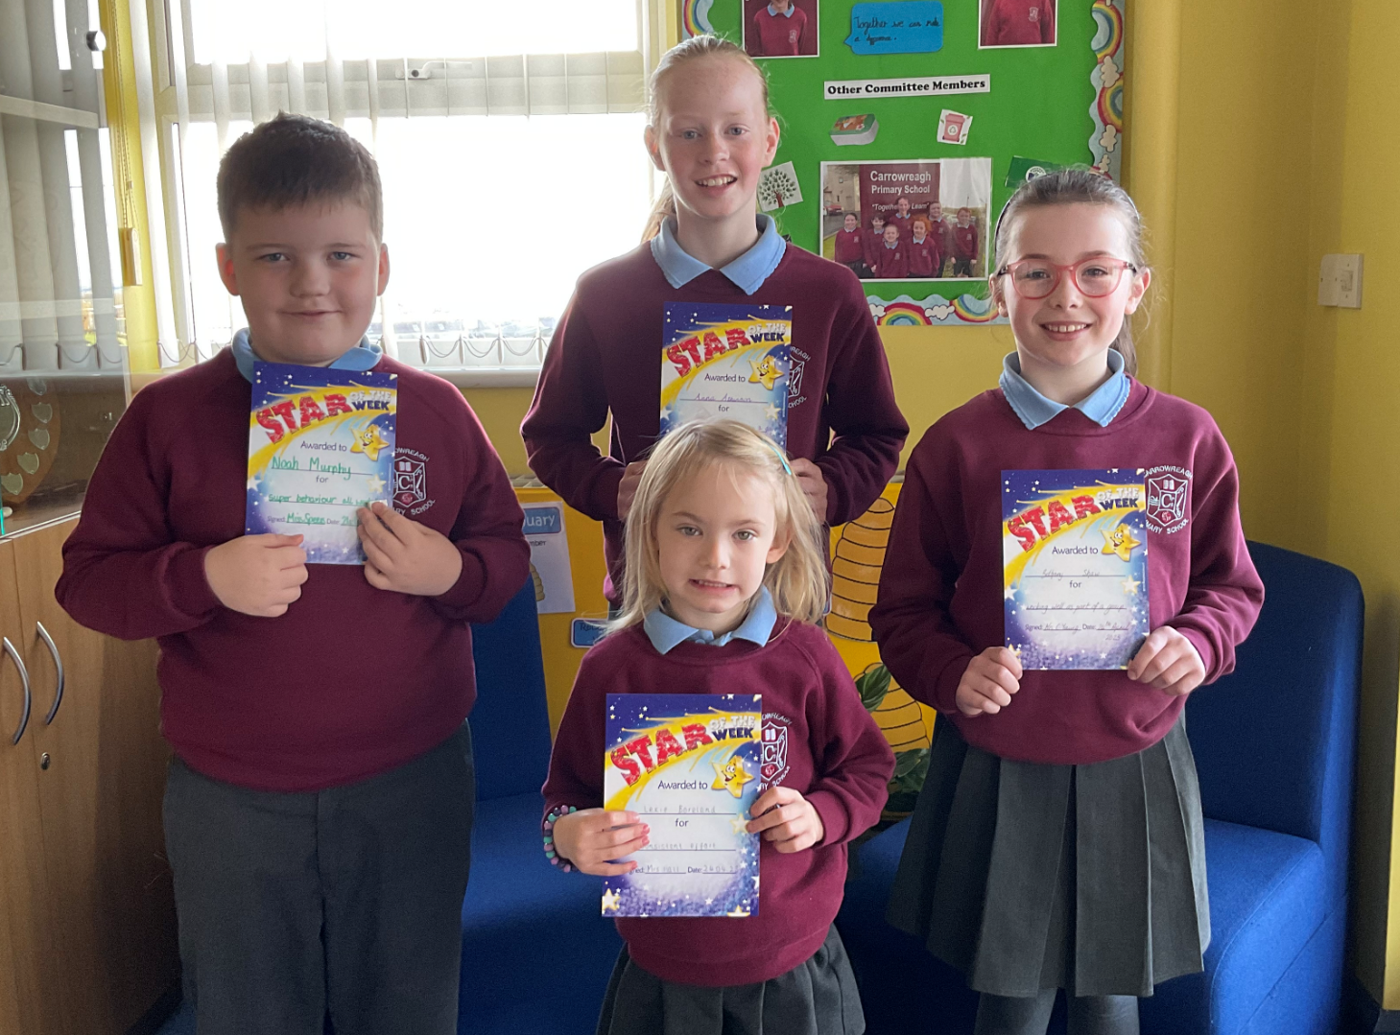

THE CURRICULUM
The Northern Ireland Curriculum is implemented in full throughout the school. Pupils’ knowledge is supported by the development of skills and understanding. It is recognised that when pupils develop key skills through their work their learning will be much more meaningful and will stay with them for life.

Language and Literacy
Talking and listening which includes stories, poetry, rhymes, drama and Community of Enquiry.
Reading which includes phonics, comprehension, library skills.
Writing which includes a wide range of forms of writing, grammar, punctuation, handwriting, and spellings.

Mathematics and Numeracy
Number, measures, shape and space, handling data and the processes involved in getting the answers.

The World Around Us
Through a wide variety of topics incorporating skills and knowledge of interdependence, place, movement and energy and change over time.

Personal Development & Mutual Understanding

Learning about themselves and how they interact with others, and the society and world in which they live.

Physical Education
Incorporating Athletics, Dance, Games and Gymnastics.

The Arts
Art and Design, Music and Drama.

RE
Learning through Play is an important part of the Foundation Stage timetable.

The Northern Ireland Curriculum develops the Cross-Curricular skills of Communication, using Mathematics and using ICT. Other skills developed are thinking, problem solving and decision making, self-management, working with others managing information and being creative. These skills are infused throughout the children’s work in all curricular learning areas
ASSESSMENT & REPORTING
Assessment for learning is at the heart of the process of promoting children’s learning.
Children with learning difficulties may be referred to the school’s Special Educational Needs Co-ordinator for assessment beyond the normal class procedure.

Key Stage Assessments are carried out at the end of Key Stage One (Year 4) and Key Stage Two (Year 7). The children are given a level in Using Mathematics, Communication and Using I.C.T.

Parents are invited to attend a meeting with their children’s teacher in October/November to discuss progress and set targets to work on during the school year. A second meeting is arranged in February/March.

Annual Reports are sent home, at the end of the school year, in June.

RECEPTION PROVISION
Reception pupils will follow guidelines set down by DENI for pre-school education. We will seek to provide a rich variety of challenging play activities and other experiences in a stimulating environment. They will be given opportunities to learn at their own pace, gain a positive image of themselves as learners, be able to cope with uncertainty and to learn through trial and error.

DESTINATION OF 2022/23 SCHOOL LEAVERS
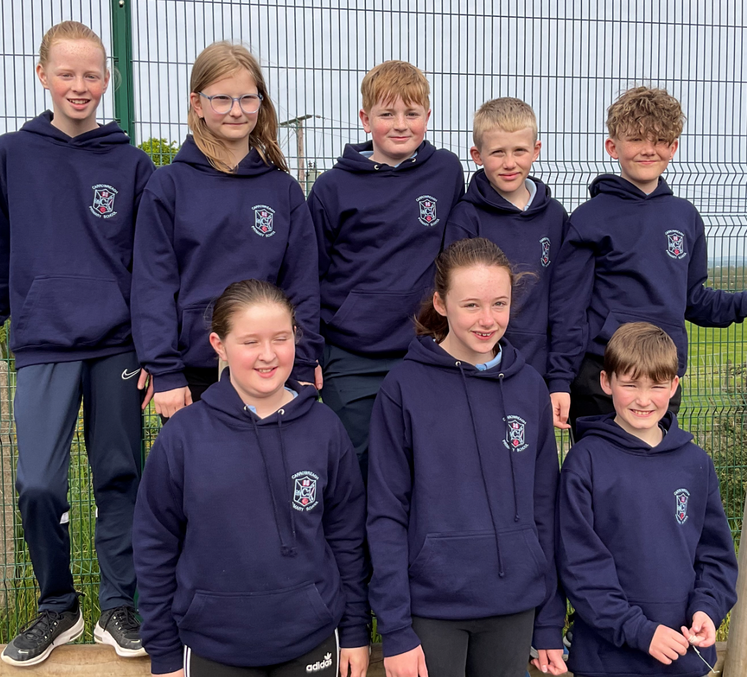
Ballymoney High School
Dalriada Grammar School
Ballymena Academy
Cullybackey College
Our Lady of Lourdes High School

SPECIAL NEEDS
Detailed assessment by teachers, both formal and informal, ensures that children who are encountering difficulties with any area of the curriculum are detected early. All class teachers have been trained to identify and teach pupils with learning difficulties and parents will be informed if it is recommended that their child should be placed on the Special Educational Needs register. We strive to identify pupils who may be struggling in any element of the curriculum early so that support can be put in place. This support may only be necessary as a temporary measure but will stay in place as long as the pupil requires it.
Small groups of children who require help with phonics, reading or mathematics are supported by a teacher and/or a classroom assistant. Use is also made of the specialist peripatetic services provided by EANI. The school’s “Special Educational Needs Policy” addresses all the requirements of SENDO (Special Educational Needs and Disability Order) and the Code of Practice on the “Identification and Assessment of Special Educational Needs” (D.E.N.I.).

SCHOOL DEVELOPMENT PLAN
Our new School Development Plan outlines the steps being taken for the next three years and for the 2023/24 year in detail, in order to be a continually improving school.

PASTORAL CARE
Each teacher has a very important pastoral role. The class teacher guides and counsels each child in their care.

A copy of the Child Protection policy is available to all parents. Through this policy we seek to support every child’s development in ways which will foster security, confidence and independence.

The Designated Teacher with responsibility for Child Protection is the principal, Mrs D Crawford.
The Deputy Designated Teacher is Mrs C Young.

ADDRESSING BULLYING POLICY
This ensures that children and parents are aware of what bullying is, the effects it has on the victim and bully and explains that it is not tolerated in this school.

Parents and children are encouraged to contact the teacher or Principal as soon as possible with any concerns in this area.

ADMINISTRATION OF MEDICATION
The school is committed to the development of a high quality response to the issue of drugs education, and copies of The Administration of Medicine policy are available from school.

Teachers are not permitted to administer drugs in school and pupils should not have any type of medication (except Asthma treatments) with them. Pupils who are on short-term medication will be allowed to take this in school provided the appropriate consent forms are completed and signed by parents. Children who require medication for a life-threatening illness are exempt from this; but written permission will have been given to the class teacher at the beginning of the year or on diagnosis.

POSITIVE BEHAVIOUR POLICY
The school reinforces and rewards both the good behaviour and the hard work and effort among pupils of all ages. Good discipline is essential to create an environment, in which children are both happy and productive.

A copy of the school’s Positive Behaviour policy is available to all parents. Classes operate ‘Golden Time’, which is a period of free time, where pupils choose an activity they wish to do. It is used to reward good behaviour. Time is withdrawn for misbehaviour or lack of effort.

On occasion it may be deemed necessary to place individual pupils onto a ‘behaviour chart’. These charts will give opportunity for pupils to be rewarded for good behaviour and will provide information for parents when pupils’ behaviour has not been acceptable.

HEALTH & SAFETY
In accordance with statutory requirements, all children in the school are involved in evacuation procedures once per term.

We aim to make pupils aware of safety procedures needed in respect of hazards in the home, en-route to school and in the school. The police, drugs officers, doctors, dentists and nurses are invited to talk to the children regarding their health and personal safety.

All members of staff have knowledge of basic first aid and there is always at least one qualified ‘First Aider’ in school. It is the policy of the school that the class teacher, in consultation with the ‘First Aider’, will make a decision regarding the notification of parents when a child becomes ill or sustains an injury during school hours.

Risk assessments are completed before each out of school activity or trip. Parents complete and sign a permission form to allow their child participate in any out of school activities.
Parents should ensure that the school office is aware of where they can be contacted in the event of an emergency, (particularly if telephone number or place of contact changes).

ILLNESS
Pupils should not return to school until at least 48 hours after all the symptoms of the illness have disappeared. Work will be sent home if the child is well enough to complete it and the parent requests it.

A note on return to school and an email/telephone call explaining absence is required.

HOMEWORK
All pupils have homework and the parents’ support and encouragement in this is vital to the child’s success at school. The amount and nature of this will depend upon the age and needs of the child and is outlined in the Homework Policy available to all parents. Homework information is provided each week via our online communication platform Microsoft Teams. Homework should be signed by a parent/guardian.

HOME-SCHOOL LINKS
Parents are partners with school and, as such, are encouraged to play a vital role in their children’s education.
All of the staff work closely with parents to ensure the welfare of children in school and will be pleased to discuss matters of concern as well as the pupil’s progress.

Appointments with staff may be made by telephoning school or sending a note with pupil. A school newsletter is shared at the beginning of each month to keep parents informed of recent events or achievements as well as any forthcoming activities.

Parents are also invited to attend several social and fund-raising activities throughout the year.

SCHOOL FUNDS
All parents are asked to contribute to School Funds at the beginning of the school year. This contribution is £20/child or £30/family. This money helps towards the cost of school trips and other items throughout the year.

P.T.A.
The Parent-Teacher Association is an active group within the school. Over the last few years, they have been responsible for purchasing various items of classroom equipment, including our school iPads and helping with the installation of our outdoor Adventure Trail. All parents are encouraged to support the fund-raising activities organised by the committee. The extra resources provided by P.T.A. are vital to the success of the school.

SCHOOL MEALS
School Meals are available at a cost of £2.60 per day or pupils may bring a packed lunch.
Supervisory assistants supervise the children during the lunch break. A copy of the menu is sent home and available to view on the school website. Pupils may choose with their parents if/when they would like to eat school dinners.
(Fizzy drinks are not permitted in school).

SCHOOL MILK
A milk scheme operates within the school and a form should be filled out at the beginning of each term/half term. A carton of milk costs 21p per day. Milk is provided free of charge for Reception pupils.

HEALTHY EATING
The school is committed to encouraging healthy eating, so pupils are given time to eat a healthy snack and have a carton of milk, or still water in the classroom at break.

Guidelines have been issued by the EANI Healthy Breaks Scheme. Healthy snacks include fresh or dried fruit or vegetables, a sandwich with a savoury filling, pancakes, breadsticks, crackers, plain fruit yoghurt.
A healthy break (toast) is provided by school and you can pay for this on a monthly basis, £5 per month.

Crisps, sweets and chocolate are not permitted at break time.

Children should have a bottle of still water with them, as they are encouraged to drink water during the day to prevent dehydration. Children are not permitted to have drinks or sweets with artificial colouring in school, as these affect their behaviour and concentration levels throughout the day.
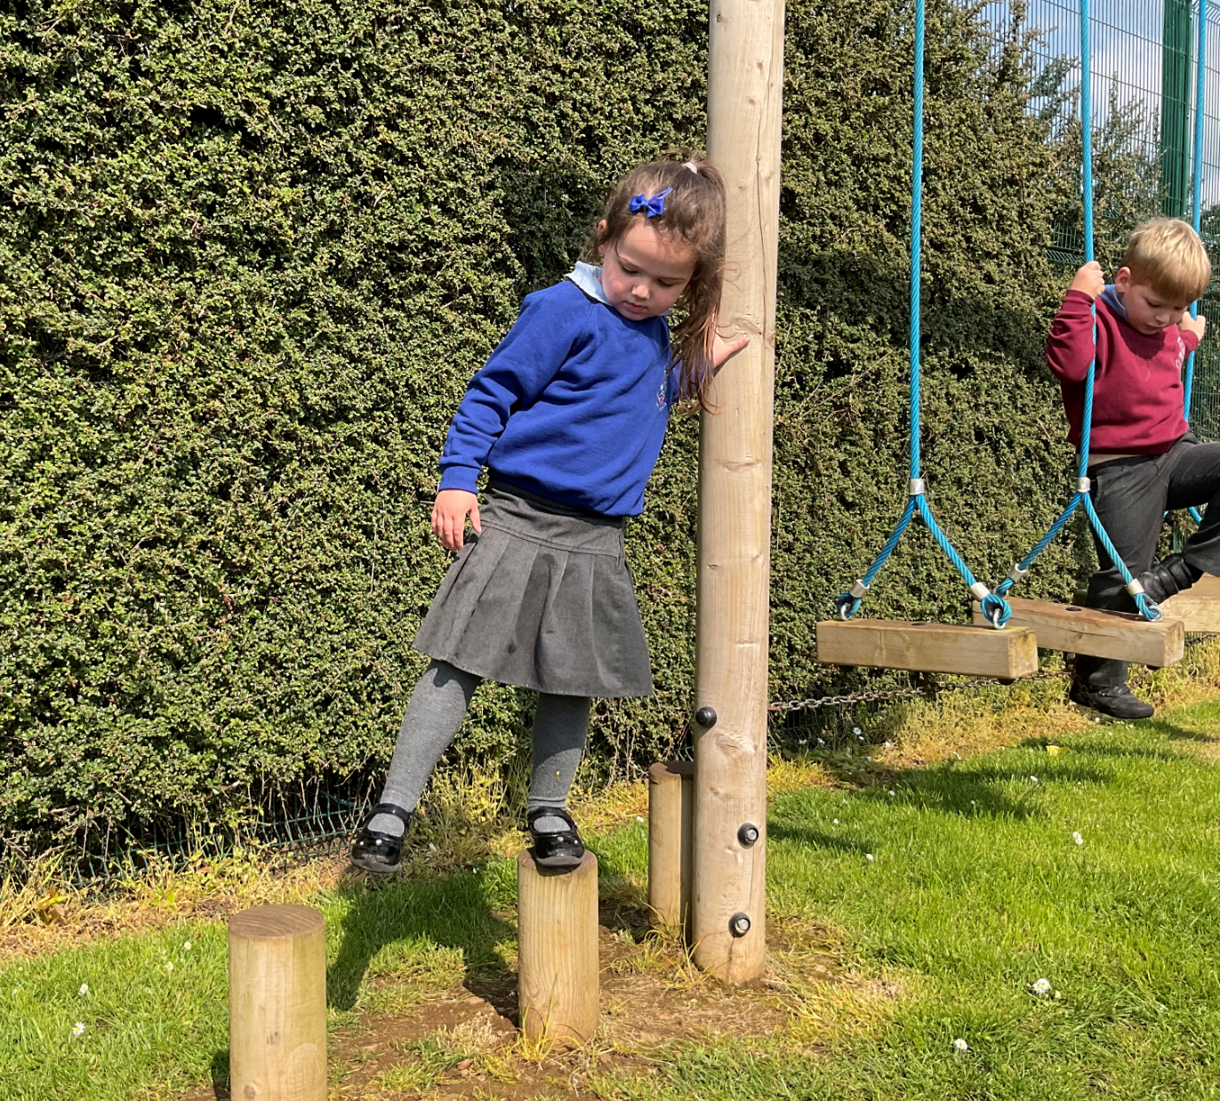


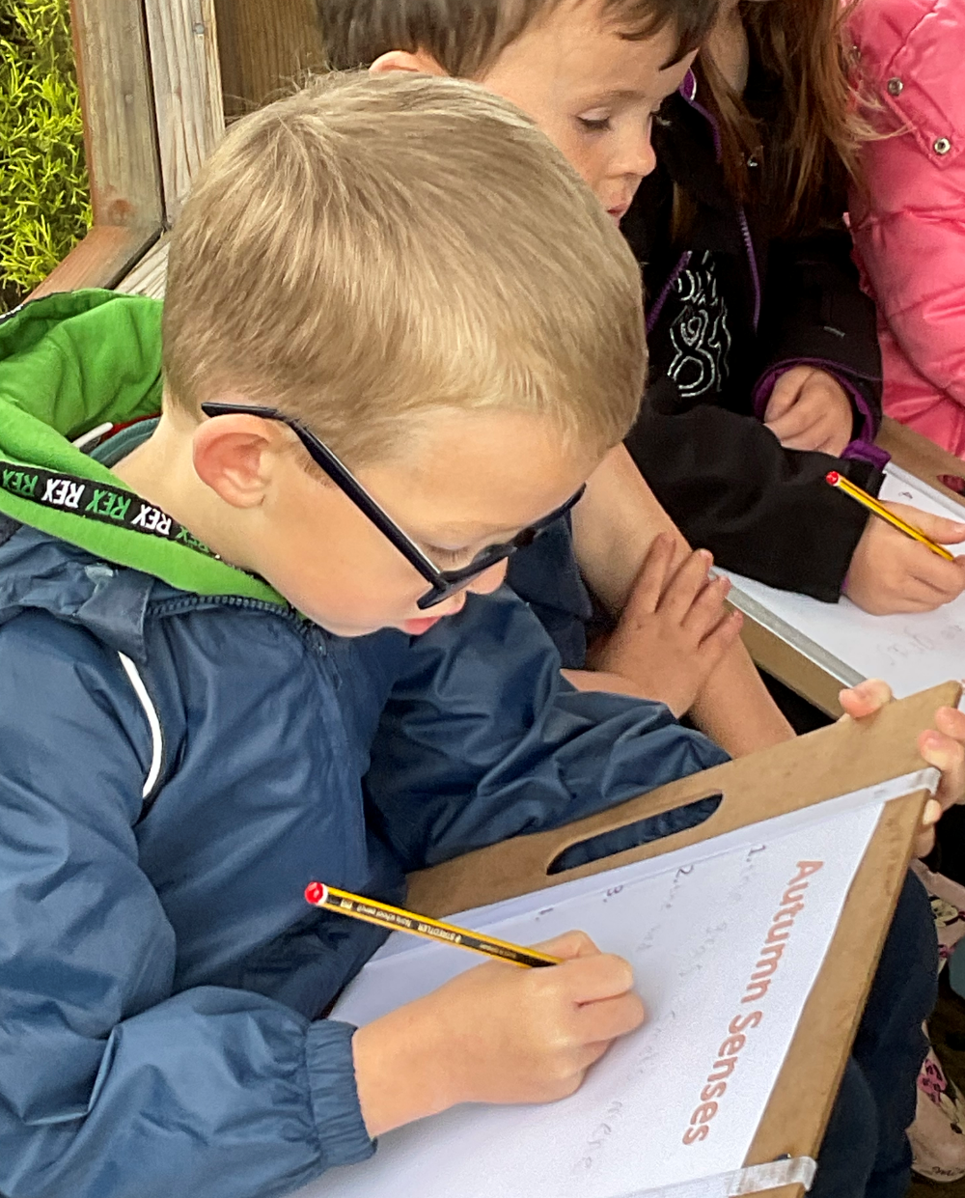

PROPERTY
Whilst every care is taken of pupils’ property, no responsibility can be accepted for loss or damage. Items of uniform should be clearly labelled. Children should NOT bring mobile phones to school. If for any reason you feel they need to bring one to school, for example if going to someone else’s house after school, it must be turned off and given to the child’s teacher in the morning. Items of value should not be brought to school, for example, iPad etc.

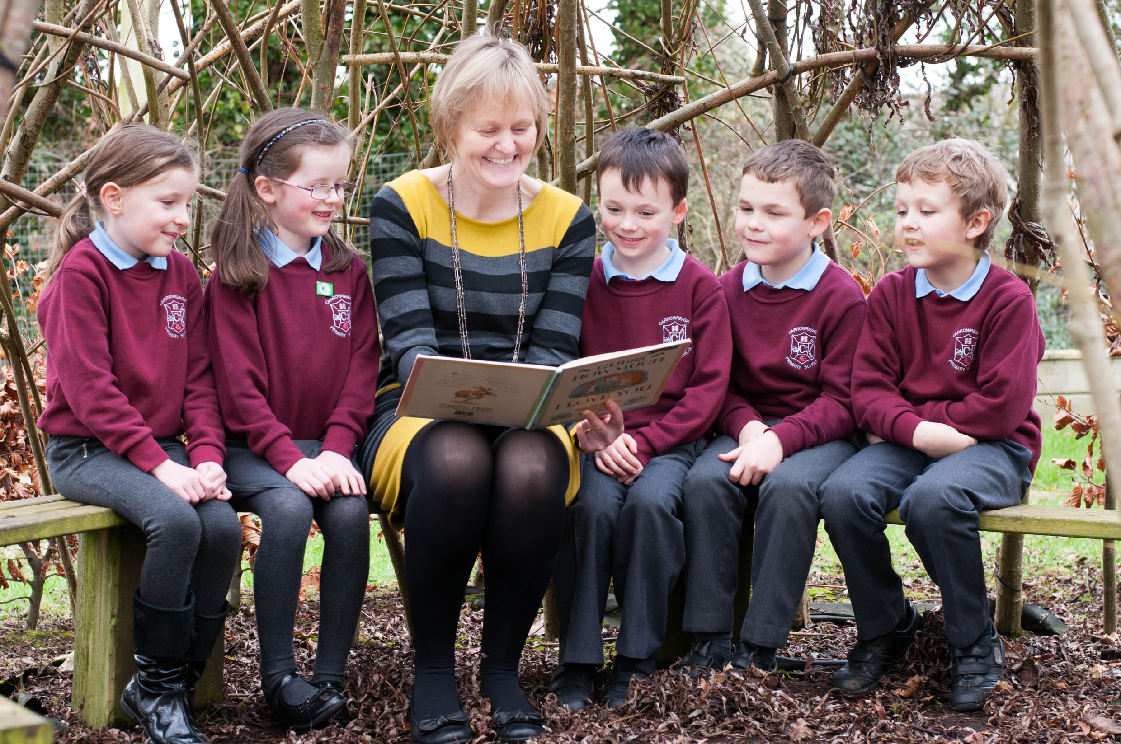

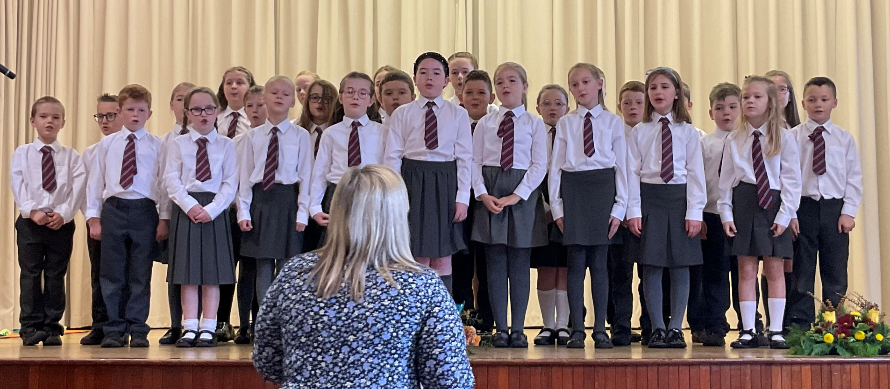
SCHOOL UNIFORM
School uniform is desirable and removes the element of ‘competition’ among pupils. It also teaches our young people what it is to be part of a community and encourages respect for themselves and their school.
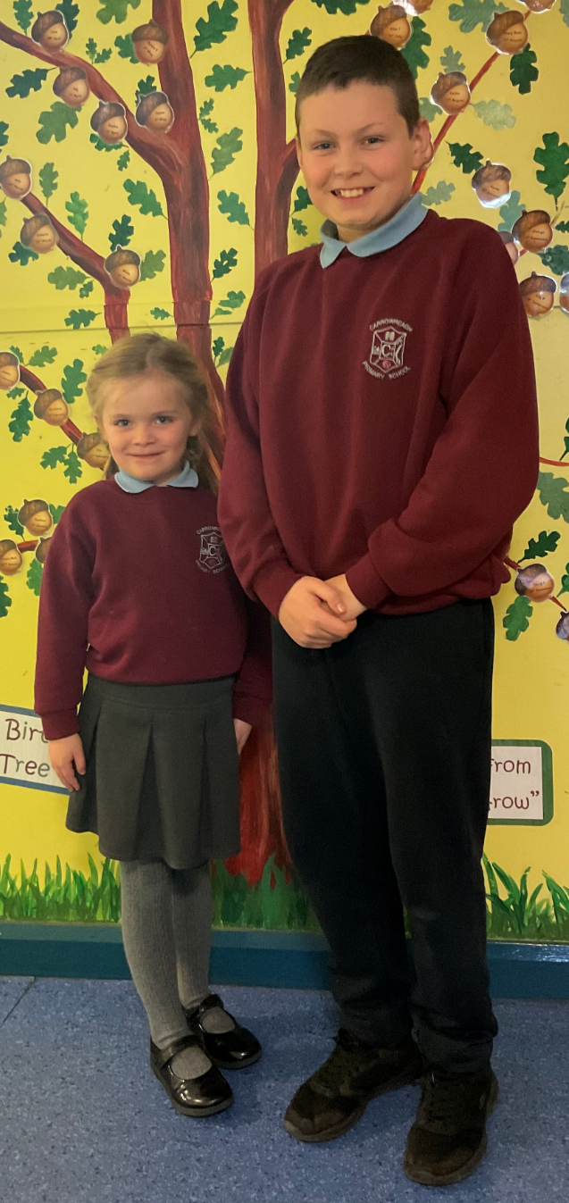
Boys
Grey trousers
Light blue polo shirt
Maroon sweatshirt (with school logo)
Black shoes

Girls
Grey skirt or trousers
Light blue polo shirt
Maroon sweatshirt (with school logo)
Black shoes

P.E. uniform
Plain navy jogging bottoms and light blue polo shirt
Trainers

Reception Pupils
Navy tracksuit bottoms
Royal blue sweatshirt (with school logo)
Light blue polo shirt

Children representing the school in competitions etc. may be asked to wear formal school uniform.
White long sleeved school shirt/blouse and school tie.
Grey skirt/trousers
Black shoes

N.B. School sweatshirts and outdoor coats can be purchased from the school office.

It is essential that all items of school uniform, especially sweatshirts and coats, are clearly marked with the child’s name and class.

ATTENDANCE
Last year’s percentage attendance figure was 94.1%, well above the NI average. If a child is absent for any reason, we ask that parents inform us at the earliest convenience by email/telephone. A note should be sent with the child upon their return explaining the reason for absence.

LEAVING SCHOOL DURING SCHOOL HOURS
A letter should be sent to the class teacher requesting permission to leave school. Children will not be permitted to leave school during the school day unless their parent or another authorised adult collects them.

HOLIDAYS DURING TERM TIME
School holidays are sent out to parents in June. It is advisable to try to arrange the family vacation during these dates as prolonged absences from school leads to an interruption in learning programmes and pupils may fail to master vital concepts missed during that time. School will not provide schoolwork for children when on holiday during term time.
Where parents do decide to go on holidays during term time, the principal should be informed. A letter in advance of the holiday will suffice. It is important to note this does not mean your child(ren) will be marked present at school. This is still considered a school absence.

CHARGING POLICY
Parents are asked to make a voluntary donation to school funds annually. Currently this is £20 per pupil or £30 per family. This money assists in paying school trips as well as certificates, sports day prizes, special visitors etc.

It is the policy of the school to subsidise the cost of trips and activities as far as reasonably possible. However, with the increasing cost of transport hire, admissions, extra-curricular resources, sports coaching etc it is now necessary to ask parents to contribute to such costs.

Charge may be made for the following things…
- the cost of some materials for art and craft, if the child wishes to take home the finished product
- clubs where a cost to the school is incurred, eg Sports coaching from the Joey Dunlop Centre and/or Grassroots Football Coaching from IFA
- costs of admission to places of educational interest
- assistance with transport costs to trips, tournaments etc
- the cost of replacing defaced, damaged or lost text books or school equipment
- instrument tuition provided by the EANI Peripatetic Music Service.
A copy of the school ‘Charges and Remissions Policy’ is available for parents.

CHARITY COLLECTIONS
The school encourages the pupils to consider and support those who are less fortunate in life. Money is collected at specific times in the year for various charities, chosen in advance.

Money is also raised throughout the year for School Funds. This money helps to pay for end of year trips, awards, prizes and expenses from extra-curricular activities.

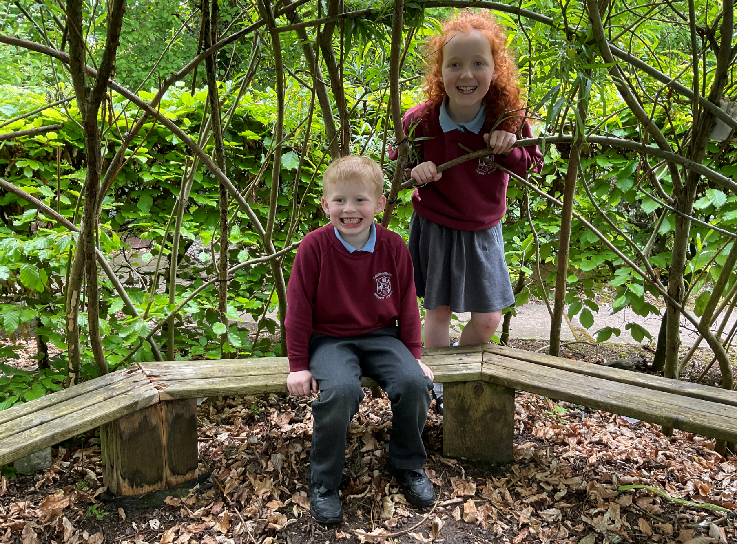

EXTRA CURRICULAR ACTIVITIES
Pupils take part in a wide range of extra-curricular activities here at Carrowreagh Primary School.
There are a variety of after school activities run by teachers and external sports coaches, for pupils in P3 – P7. These include Multi-sports, Basketball, Table-tennis, Crafty Kids, Cookery Club, Football, Hockey, iPad Club, STEM Club, Gardening Club, Drama club, Music Makers, Shine Club and P6/7 Revision Clubs.

Cycling Proficiency is held in the summer term for P7 pupils.

We also offer a number of sports coaching sessions which are conducted by staff from Joey Dunlop Leisure Centre. These vary from year to year but aim to give children coaching in fundamental sports skills.
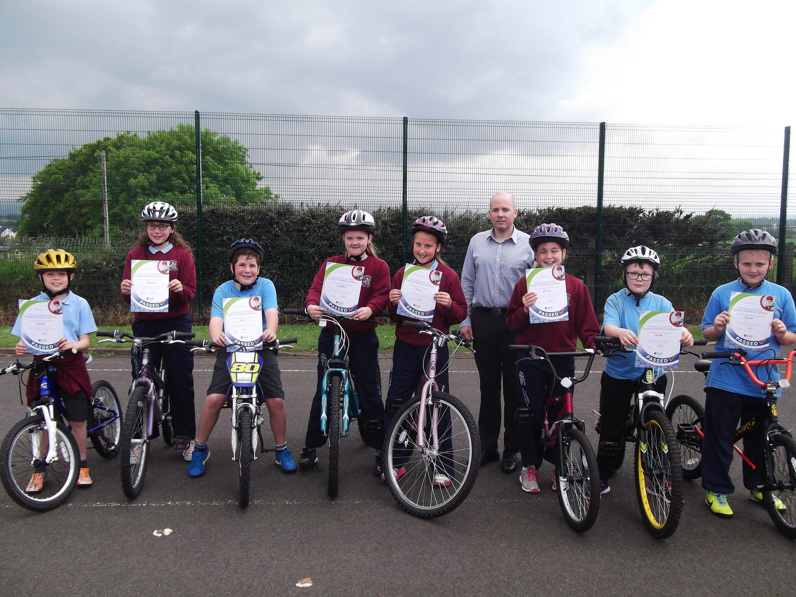

BREAKFAST CLUB
Bright Reaghs Breakfast Club runs daily from 8am. Toast, cereal and fruit juice is provided, and children are supervised by a member of staff. The cost is £1.00 per day.

AFTER SCHOOL CARE
Throughout the year we endeavour to provide after school care for foundation stage pupils from 2pm – 2.45pm. A classroom assistant is employed to run Little Reaghs After School provision and this will run (dependent on numbers) at a cost of £2.50 per session.



This Photo by Unknown Author is licensed under CC BY-SA-NC
Check us out on Facebook and X for recent updates and activities!!

